- OBSERVER PATTERN on 12-07-06
By
Venkata Thippanna Rao. P. R.

- Pattern Name: Observer

- Reference: “Head First Design Patterns”

- Definition: Observer pattern defines a one to many relationships between a set of objects and when ever the state of the subject changes all its dependants or the observers are notified and updated accordingly.

- Description:
  - In this pattern there will be a Subject which holds a state or a content and a set of observers who are interested in that state change or content change.
  - The observers got to be registered with the Subject and the Subject would notify the observers when ever the state or content changes.
  - The observer can get detached themselves from being an observer by unregistering.
  - The Subject is an Interface and there will be concrete classes holding the state information which implements the Subject interface.
  - What if the Observers need different sort of Information? : The Observers should implement the Observer interface that holds the prototype of the communications between the Concrete Observers and the Concrete subject. Generally the Update() method with a standard prototype for a groups of users is defined.
  - And if other groups of users need other type of updates yet another Observer interface can be created and so on.
  - Where to have the Subject object declared? : And it can be Observed that the object of type Subject interface type can be declared either in the Observer interface or the Concrete observers, this is for registering purpose. It does not effect much how ever I feel it is preferable to be in the Interface. So that the standard is maintained. I feel so because having a declaration in the Observer interface makes a standard to be adopted by its implementers. So that the code can be easy to trace out for many implementers of the same Observer interface. But, in the Head First design patterns it is declared in the concrete observers.

- UML Notation/ Diagram:
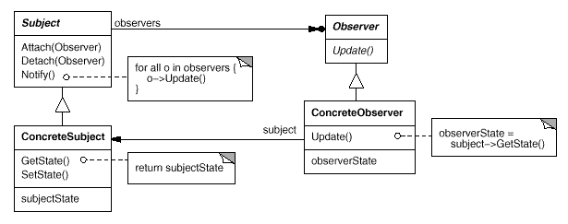

- Design Principles:
- Strive for the loosely coupled designs between objects.
- Program to interfaces not to implementation.
- Separate the things that change from the things that remain the same.
- Prefer Composition over inheritance.

- Application Areas:
Observer patterns are employed exclusively in
  - JDK
  - Java Beans
  - RMI
  - Swings

- Thought Process:
  - Here “Strive for the loosely coupled designs between objects” means that the Subject that notifies the Observers does not have any idea, what are the methods or properties of the observers or what the observers do with the updated data. It only knows the handle in the raw sense. It communicates by means of an interface here i.e.., the observer interface’s update method which is a standard prototype for all the observers as well as the Subjects.
  - The type of notifications for different types of observers can be done as explained in the description part of this pattern.
  - The ease of declaration of the Subject object that is either in the interface or the concrete implementers discussed in the description part as well.
  - Here “Separate the things that change from the things that remains the same” is employed as the state of the subject is the thing that varies in the observer pattern. And so, an interface is created to have it encapsulated.
With this one can change the observers or objects that are dependent on the state of the subject. This is called Planning Ahead.
- Here “Program to an Interface, not to an implementation” is done as the subjects and the observers are both implementing the necessary interfaces. This actually keeps the things loosely coupled.
- Here “Prefer Composition over inheritance” is done as the Observers got to compose the Subject interface object such that, it can be dynamically be allocated to the respective State and Subject.

